**Bibliometric Analysis on Islamic Entrepreneurship, Islamic Finance and Sustainable Development Goals (SDGs): Study Based on the Scopus Database**

**Neni Hardiati Tresna**

Doctoral Study Program in Islamic Economics and Halal Industry

Graduate school, Gadjah Mada University Yogyakarta Indonesia

tresnahardiatineni@gmail.com

|  |  |
| --- | --- |
| **Article Information** | **Abstract** |
| E-ISSN : 3026-6874  Vol: 3 No: 6 June 2025  Page : 95-107  **Keywords:**  *Islamic Entrepreneurship, Islamic Finance, Sustainable Development Goals (SDGs)* | Objectives - Intellectual curiosity about Islamic entrepreneurship, Islamic finance and Sustainable Development Goals (SDGs) whose issues have increased recently in various sharia sectors. Design/Methodology/approach **-** Based on the scopus database, descriptive bibliometric analysis with the visualization tool VosViewer was used to assess 385 documents on Islamic entrepreneurship, Islamic Finance and SDGs, which peaked in 2024 based on the period of 2010-2024. Findings-This study found many articles on Islamic entrepreneurship, Islamic finance and the SDGs. According to this study, Malaysia is the country that publishes the most publications of this research compared to other countries. Then the University of Brunei Darussalam was the most prolific affiliate to publish articles on this. The history of article production growth that started from 2010-2024, continues to increase and peaks in 2024, with 55 documents and the lowest number of documents in 2010 with 10 published documents. This is increasing because there may be a need for sharia synergy to increase Islamic entrepreneurship in Islamic finance and sustainable development (SDGs). Romadoni, V as the most prolific writer about this research. Islamic entrepreneurship, Islamic finance and SDGs provide the potential for sustainable development and is in line with the goals of sharia, namely maqashid sharia for the benefit of the ummah, this encourages sustainable development (SDGs) through Islamic entrepreneurship and Islamic finance. Practical Implications - Research can be used as a useful research proposal for future researchers who use bibliometric methods in systematic literature review by introducing the network of various variables related to this research, then by getting to know famous authors in the field can provide opportunities to collaborate for further research. In addition, this study makes it easier for future researchers to be able to expand even more by looking at the variables obtained in this study as gaps to be researched further. |

***Abstract***

Tujuan - Keingintahuan intelektual tentang kewirausahaan Islam, keuangan Islam dan Tujuan Pembangunan Berkelanjutan (SDGs) yang akhir-akhir ini isunya semakin meningkat di berbagai sektor syariah. Desain/Metodologi/Pendekatan - Berdasarkan database Scopus, analisis bibliometrik deskriptif dengan alat visualisasi VosViewer digunakan untuk menilai 385 dokumen tentang kewirausahaan Islam, Keuangan Syariah, dan SDGs, yang mencapai puncaknya pada tahun 2024 berdasarkan periode 2010-2024. Temuan - Studi ini menemukan banyak artikel tentang kewirausahaan Islam, keuangan Islam dan SDGs. Menurut studi ini, Malaysia merupakan negara yang paling banyak menerbitkan publikasi penelitian dibandingkan dengan negara lain. Kemudian Universitas Brunei Darussalam adalah afiliasi yang paling produktif menerbitkan artikel tentang hal ini. Riwayat pertumbuhan produksi artikel yang dimulai dari tahun 2010-2024 terus meningkat dan mencapai puncaknya pada tahun 2024 dengan jumlah 55 dokumen dan jumlah terendah pada tahun 2010 dengan jumlah 10 dokumen yang dipublikasikan. Hal ini meningkat karena sinergi syariah mungkin diperlukan untuk meningkatkan kewirausahaan syariah dalam keuangan syariah dan pembangunan berkelanjutan (SDGs). Romadoni, V sebagai penulis yang paling produktif dalam penelitian ini. Kewirausahaan Islam, keuangan syariah dan SDGs memberikan potensi untuk pembangunan berkelanjutan dan sejalan dengan tujuan syariah yaitu maqashid syariah untuk kemaslahatan umat, hal ini mendorong pembangunan berkelanjutan (SDGs) melalui kewirausahaan Islam dan keuangan syariah. Implikasi Praktis - Penelitian dapat digunakan sebagai proposal penelitian yang bermanfaat bagi peneliti selanjutnya yang menggunakan metode bibliometrik dalam tinjauan literatur secara sistematis dengan memperkenalkan jaringan dari berbagai variabel yang terkait dengan penelitian ini, kemudian dengan mengenal para penulis yang terkenal di bidangnya dapat memberikan peluang untuk berkolaborasi untuk penelitian selanjutnya. Selain itu, penelitian ini memudahkan peneliti selanjutnya untuk dapat mengembangkan lebih jauh lagi dengan melihat variabel-variabel yang didapatkan dalam penelitian ini sebagai celah untuk diteliti lebih lanjut.

**Kata Kunci:** Islamic Entrepreneurship, Islamic Finance, Sustainable Development Goals (SDGs)

**INTRODUCTION**

Islamic entrepreneurship comes from basic principles sourced from the Quran and as-sunnah. In addition, Islamic entrepreneurship is different from conventional entrepreneurship that originated from the west, in Islamic entrepreneurship uses the fiqh method in overcoming various contemporary issues which include five aspects such as assessing intentions and objectives, overcoming doubts, making it light in difficulties, limiting dangers, and fulfilling specially made laws. (Ahmed & Aassouli, 2022) (Yasmeen, 2024) Meanwhile, in Islamic finance it must be in accordance with Islamic rules and has been stipulated in halal economic development where there is no riba, gharar, maisyir also which contains haram (Zaib et al., 2021) things. Previous research has said that entrepreneurship and entrepreneurship in accessing finance are still obstacles, so there must be generosity on the part of financial institutions to overcome the development of entrepreneurs with sustainable access to finance (Hagawe et al., 2023). Basically, that the goals of Islamic law (Maqasid sharia) and sustainable development goals (SDGs) pioneered by the United Nations (UN), have the same purpose and purpose in achieving prosperity for the sake of sustainable development. humanitarian life, so that Islamic finance supports in the SDGs for sustainable human life. (Burhanudin Harahap, 2023)

Muslim-majority countries have higher levels of poverty and fewer scores on achieving the sustainable development goals set out in the SDGs. However, various studies show that finance has a sufficient contribution and support in implementing sustainable development (SDGs). Previous research has shown that Islamic (Khan & Haneef, 2022) financial assets continue to grow globally (see Figures 1 and 2). In 2020, Islamic finance claimed a slowdown of 14% from 2019, and up to 15% of this was due to the impact of the covid-19 pandemic, a report from Refinitiv projects the growth of Islamic financial assets to reach USD Global Islamic Financial Assets are estimated to reach USD 3.69 trillion by 2024.

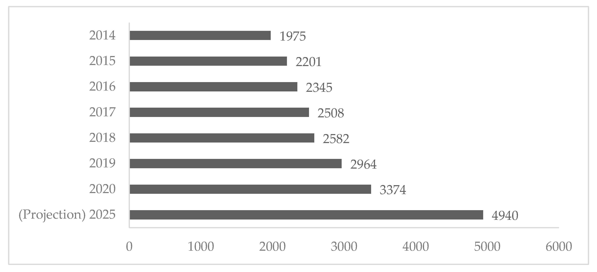

*Image Source 1*

*Growth of Islamic financial assets globally (in billions of USD). (Burhanudin Harahap, 2023).*

Furthermore, in Figure 2, for this market share, global Islamic financial assets are around 70% or equal to the value of USD 3.24 trillion, showing that banking in the Islamic context has been the main driver in the overall growth of the industry in the last ten years.

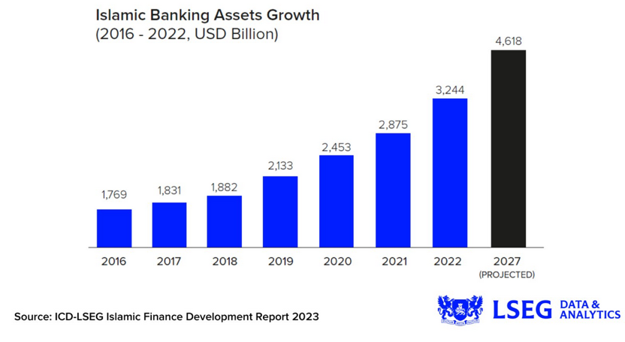

*Source of Image 2*

[*https://www.lseg.com/en/insights/data-analytics/navigating-uncertainty-global-islamic-finance-assets-expected-to-exceed-67-trillion-by-2027*](https://www.lseg.com/en/insights/data-analytics/navigating-uncertainty-global-islamic-finance-assets-expected-to-exceed-67-trillion-by-2027)

The world's Islamic finance industry has increased its asset size by 11% to US$4.5 trillion in 2022, in the latest ICD-LSEG Islamic Finance Development Report 2023. Islamic finance is expected to continue to grow, with assets estimated to reach US$6.7 trillion by 2027. (Mustafa Adli, 2023)

Previous research on Islamic entrepreneurship, Islamic finance, and the SDGs has been extensive, but no one has tried to link the three. Various studies have investigated the existence of sustainability in Islamic entrepreneurship and Islamic finance globally. Meanwhile, various literature that examines Islamic entrepreneurship and Islamic finance are associated with the implementation of various businesses or businesses. Then, other literature has also investigated the application of SDGs in the field of education and Islamic epistemology, SDGs in the field of business such as previous research on companies in China during the Covid-19 pandemic. Later in the study highlighted that sustainable Islamic finance promotes (Sholeh et al., 2025) (Wu et al., 2024) green entrepreneurship by investing in sustainable projects, supporting SMEs, and offering alternative financing. (Lukman Raimi, 2024)

Compared to conventional finance, there are still many questions about the role of Islamic entrepreneurship and Islamic finance in sustainable development. Some perspectives of society in general also see Islamic finance only as finance that has a purely religious nature. This SLR is to fill the gap by providing a comprehensive SLR that reviews all research in the field of Islamic entrepreneurship, Islamic finance, and the SDGs, including in areas related to the SDGs that can be contributed by Islamic entrepreneurship and Islamic finance.

1. **Literature Review**

**Islamic Entrepreneurship**

Islamicand halal entrepreneurship is still in its infancy among Islamic finance professionals, halal consultants, academic researchers, and students who have ambitions to enter these two fields. Universities, Islamic training academies, and centers are also ill-equipped to enrich Islamic and halal curricula with conventional principles and models. One proactive way to break the financial exclusion, social inequality, and social exclusion caused by apathy and avoidance of usury, maysir, and gharar is to recognize, embrace, and promote Islamic and halal entrepreneurship among marginalized Muslims and lovers of good business models. ( Hunjra et al., 2024) (Raimi et al., 2023) ( Hunjra et al., 2024)

**Islamic Finance**

Islamic law is based on or rooted in sharia principles such as the absence of practices that are not in accordance with sharia principles, namely the existence of riba, gharar, maisyir and practices that are considered haram. Following the concept of Islamic finance, (Ilias, 2009) the concept in Islamic finance is a financial system that operates in accordance with Islamic law (sharia). This system differs from conventional finance in several key ways: The Core Principle is that there is a prohibition of interest (riba), which expressly prohibits payment or receipt in the presence of interest. But instead, this system promotes the regulation of profit and loss sharing. Risk sharing, financial transactions must involve some level of risk sharing between the parties involved. This is in contrast to conventional finance where lenders usually do not bear the risk. Investments should be clear and socially responsible, avoiding businesses that are perceived to be detrimental to society, involving alcohol, gambling, or pork. (Chiu et al., 2005)

It can be seen, that Islamic finance such as Islamic microfinance is a special product of Islamic financial institutions that offer capital in financing and investment services in compliance with sharia principles, to provide access to credit, savings, and insurance for the lower middle class as well as people living in underserved rural areas as well as low-income people in disadvantaged areas. Islamic finance promotes financial inclusion, entrepreneurship, and even poverty alleviation that adheres to ethical and sustainable principles. (Awan et al., 2023) (Hussein Kakembo et al., 2021) (Billah et al., 2024) This financial system is based on Islamic principles and aims to promote social justice and reduce poverty by addressing the root causes. Furthermore, Islamic social finance plays an important role in promoting financial inclusion for underprivileged communities, encouraging entrepreneurship and small business growth, and providing investment opportunities that prioritize social impact. (Aaron & Siraj, 2024)

**Sustainable Development Goals (SDGs)**

The Sustainable Development Goals (SDGs) have a framework, namely 17 global goals that were confirmed by the United Nations (UN) in 2015 as part of the 2030 agenda. It has various goals, including social, economic, and environmental challenges, including eradicating poverty, ensuring access to clean energy, water, and sanitation, promoting gender equality, combating climate change, and fostering a peaceful and inclusive society (Raimi and Lukman 2023). Islamic finance has great potential for countries that are in SGDs for sustainable finance. For example, focusing on SDGs programs, namely anti-poverty financing programs, hunger projects, renewable energy, clean water, sustainable agriculture, and environmentally friendly sectors. (Yasin et al., 2023)

*SDGs Image: Sustainable Development Goals (SDGs) by the United Nations*

Sustainable Islamic finance can play a role in SDG number 1 (no poverty), SDG 2 (no hunger), SDG 3 namely (good health and well-being), SDG 4 (Quality education), SDG 5 on (Gender equality), SDG 6 on (clean water and sanitation), SDG 7 on (affordable and clean energy), SDG 8 namely (Decent work and economic growth), SDG 10 on (reducing inequality), SDG 16 on (peace, justice, and stronger institutions), and SDG 17 on (partnerships to achieve goals), thereby encouraging inclusive and equitable development. Furthermore, the existing Islamic finance emphasis on ethical, economic, and social responsibility is also consistent with SDG 7 (Affordable and Clean Energy), SDG 6 (clean water and sanitation), then SDG 9 (industry, Innovation, and Infrastructure) and SDG 12 (responsible production and consumption), SDG 13 (climate protection measures), SDG 14 on (life under water) and SDG 15 on (life on land). (Uzochukwu et al., 2021) (Aaron & Siraj, 2024)

**METHOD**

**Bibliometric analysis**

This study uses bibliometric analysis through bibliometric literature conducted by VOS Viewer, with bibliometrics of publication content in the scopus database. This tool facilitates the analysis of data and image visualization analysis (Touti and Taïb 2023b). Bibliometrics is a field of research that measures the publication of a journal, research institution, field of research, country, or other entity. The terms bibliometrics, scientometrics, and informetrics refer to component fields related to the study of the dynamics of disciplines as reflected in the production of literature (Martínez-Falcó et al., 2024).

**Collection**

The data in this study was collected in November 2024 from the scopus database of scientific publications with the theme of "Islamic entrepreneurship And "Islamic Finance" and "SDGs" and bibliometrics with general keywords (Islamic Entrepreneurship), the use of AND to get more specific articles searched by keywords. The scopus database is used for bibliometric analysis because it contains a larger number of journals than other data such as the Web of Science (WoS). This database contains 75 million scientific articles from five thousand publishers around the world. The database also has a portfolio of nearly 16,000,000 authors and 70,000 authors. Specific information and keywords from the bibliometric analysis of journal articles (titles, abstracts, keywords, affiliations and authors) were used to explore the relevance of themes and topics in recent years. (María Isabel Esca lo na Fernández, n.d.)

**Findings**

Descriptive Analysis

The main information in (Table 1 and Figure 4) presents the overall findings of the scopus database website media analysis which is then analyzed in the vos viewer application using the technique in figure 1, it was found that the publishing period 2010-2024, with a growth rate that continues to increase by 5.5%, document types, authors, and collaboration between authors throughout that time period are also studied. Figure 2 illustrates the history of article production growth starting from 2010-2024, which began to increase steadily in 2023 with 55 documents and the lowest in 2010 with 10 published documents. This increases because there may be a need for sharia synergy to increase Islamic entrepreneurship in Islamic finance.

Figure 3 with the author who wrote about Islamic entrepreneurship as many as 10 documents by Romadoni, V as a prolific writer. Figure 4, the countries that contributed the most were Malaysia with a total of 81 documents and Indonesia as the second country with a total of 76 documents. Figure 5, The most affiliations published by the University of Darussalam with 13 documents followed by the University of Mara technology with 12 documents. Then, figure 6 shows that this study published the most in the form of articles with a percentage of 63.6%, followed by book chapters with a percentage of 19.0%, then conference papers 6.0%, books as much as 5.2% and the rest reviews and others.

In addition to figure 7, in this study there is also funding or sponsorship that provides research funds given to researchers, namely by the ministry of education malaysia with a total of 6 documents followed by the social science and humanities research council as many as 3 documents. Figure 8, the field of business, management and accounting journals is the top that researches this field with a percentage of 30.2% and as many as 224 documents, then followed by the field with social science subjects as much as 22.1% with many 164 documents, economics, econometrics and finance as much as 21.7% with many documents 161 and other subjects.

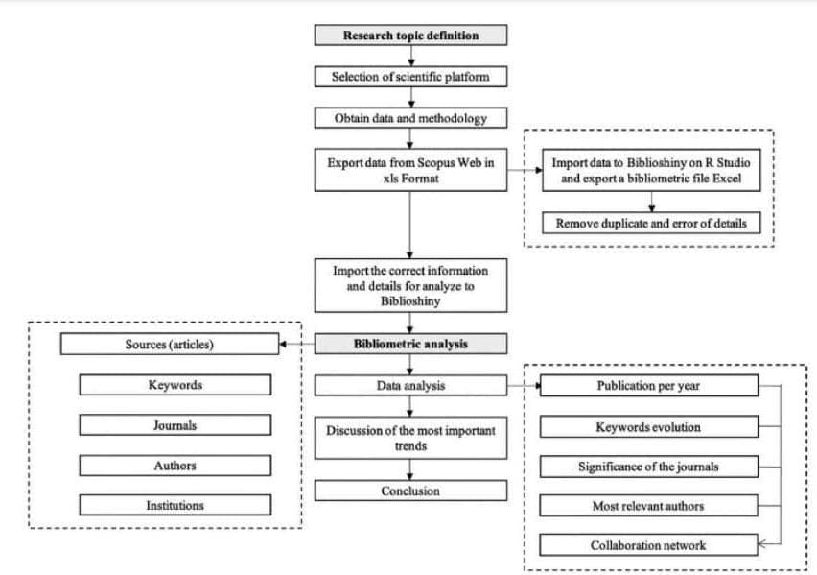

Source: (García-León et al., 2021) Figure 3 Bibliometric analysis workflow

**RESULTS AND DISCUSSION**

|  |  |
| --- | --- |
| Keywords | Islamic entrepreneurship, Islamic finance, SDGs |

Table 1, 2024: by the author

In addition to the search results for the same keyword in scopus with the same keyword, this study managed to get 395 documents, but subtracted by the period automatically subtracted by 10 documents so that the final result obtained was 385 documents from scopus.com. Here's a diagram in prism;

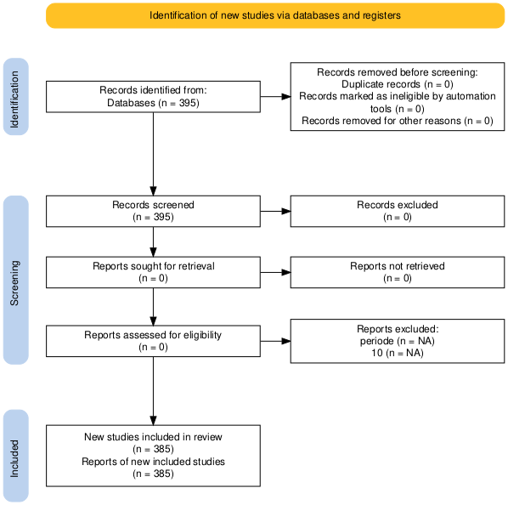

*Image Source 4: Prism flow Diagram Tool, 2024 by the author*

Furthermore, the following is an analysis of scopus.com from 2010 to 2024 with the keywords Islamic entrepreneurship, Islamic finance and SDGs.

From the image, it can be seen that from 2010 to 2024 currently, the research curve related to this continues to increase, so it can be said that this research is getting more and more people researching until the peak in 2024.

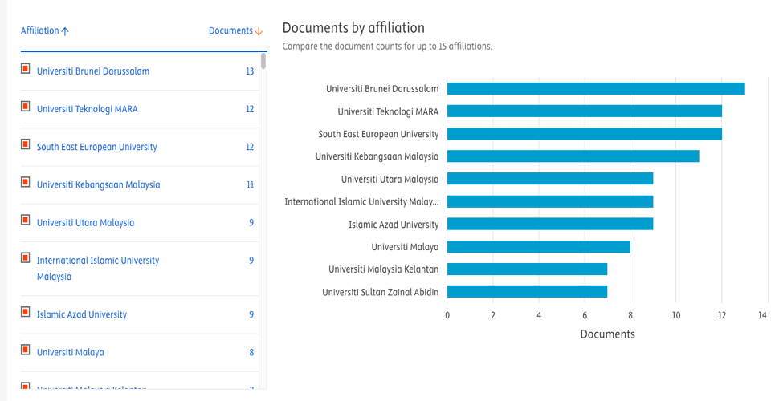

*Image source: Scopus.com (document by affiliation)*

From the image, it can be seen that Brunei Darussalam university is the most affiliated in this study, followed by Mara University of Technology, and others. The following order is in the following table;

|  |  |
| --- | --- |
| Affiliate | Number of documents |
| University of Brunei Darussalam | 13 |
| MARA University of Technology | 12 |
| South East European University | 11 |
| National University of Malaysia | 9 |
| Universiti Utara Malaysia | 9 |
| International Islamic University Malaysia | 9 |

*Table : affiliation with the number of documents, by the author*

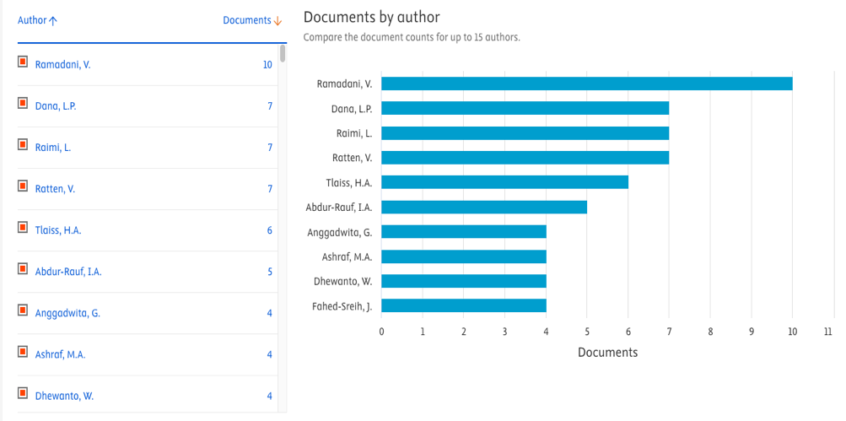

*Image source: Scopus.com (Document by author)*

When viewed from the most prolific writers who entered the first pringkar were Romadoni, V then Dana, L.O, followed by Raimi, L and other writers.

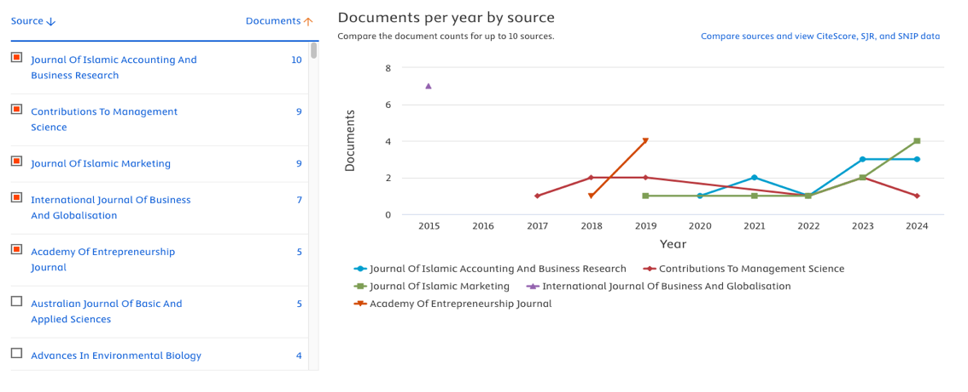

*Image source: Scopus.com (document by source)*

If you look at the picture of the *Journal of Islamic Accounting and Business Research* from 2019 to 2024 (green) is the most productive journal recently that publishes about this, then *the Journal of Contributions to management science* which continues to contribute from 2017 to 2024 even though the number is not so high but consistent, followed by the *journal of Islamic marketing* which is enough to show that it continues to contribute and get its productive peak in 2024. The following is the order in the following table;

|  |  |  |
| --- | --- | --- |
| Journal | Year | Information |
| Journal of Islamic Accounting and Business Research | 2019 -2024 | Blue Color Curve |
| Journal Contributions to management science | 2017-2024 | Brick red color curve |
| Journal of Islamic Marketing | 2019-2024 | Green color curve |
| International Journal of Business and Globalitation | 2015 | Purple color curve |
| Academy of entrepreneurship journal | 2018-2019 | Light brick color curve |

*Table: progress of research in journals, by the author*

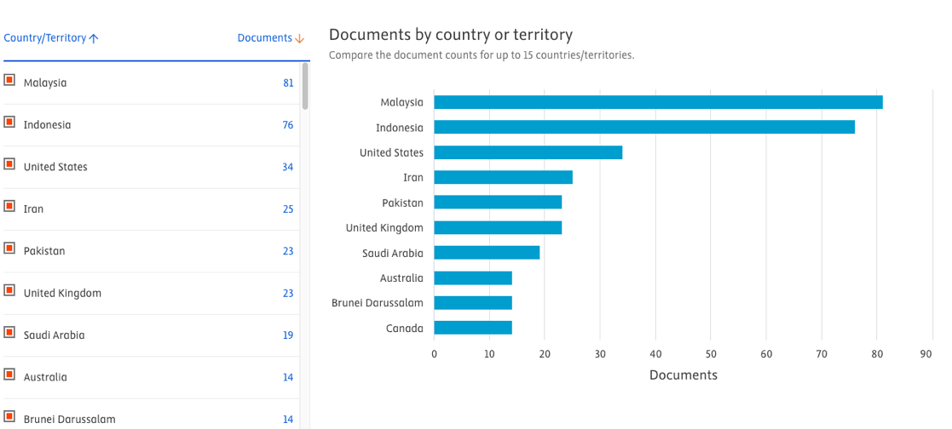

*Source: Scopus.com (document by country or territory)*

Then when viewed from the country, Malaysia is the most productive country, followed by Indonesia, the United States, Iran, Pakistan, the United Kingdom, Saudi Arabia and other countries.

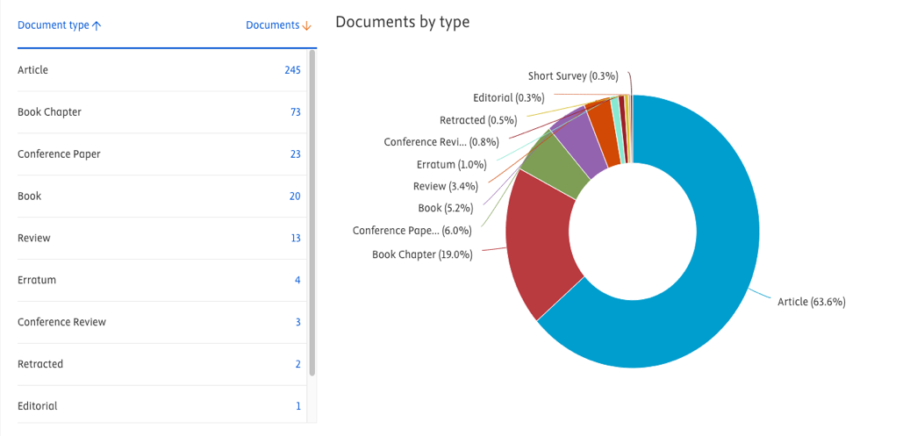

*Image Source: Scopus.com (document by type)*

Furthermore, when viewed from the type, articles are the most published, then book chapters, conference papers, books, reviews, and others.

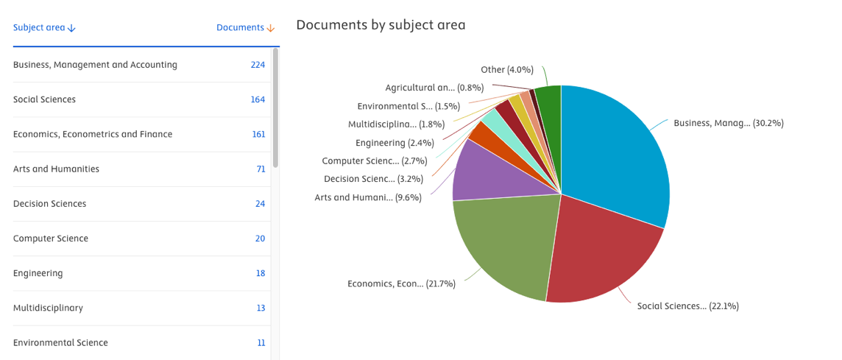

*Image Source: Scopus.com (document by subject area)*

When viewed from the subject area, it can be seen from the picture that the subjects related to Business, Management and Accounting are the most, followed by the subject area in the field of social science, economics, economics and finance, arts and humanities and other area subjects.

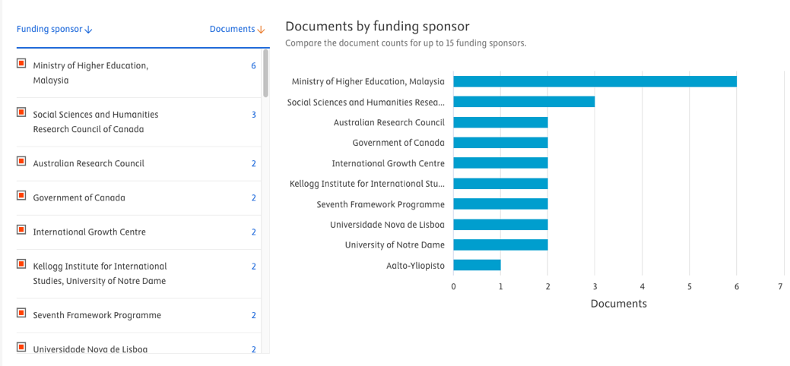

*Image Source: Scopus.com (document by funding sponsor)*

If you look at the sponsorship in publications related to this research as shown in the picture, it can be seen that the Ministry of Higher Education Malaysia provides the most funding for publications about this, followed by the Social Science and Humanities Research Council of Canada and other

Data obtained from the Scopus database in the field of Islamic entrepreneurship obtained 395 documents, then filtered in the range of the year period from 2010 to 2024 managed to get 385, with the general keyword "Islamic entrepreneurship" to see this keyword with various variables or other keywords, the keyword entrepreneurship is the most used, then followed by the keyword Islamic entrepreneurship, halal entrepreneurship, Islamic finance, and other keywords that are interrelated with Islamic entrepreneurship, as seen from the results of the Vos Viewer network visualization section (figure 4). The results of the Vos Viewer in relation to other variables, from the image it can be seen that the larger the variable looks, it means that the variable has been done a lot by the researcher, but on the contrary, the smaller and farther the relationship, then it is still a little researched, so it can be a gap for further research.

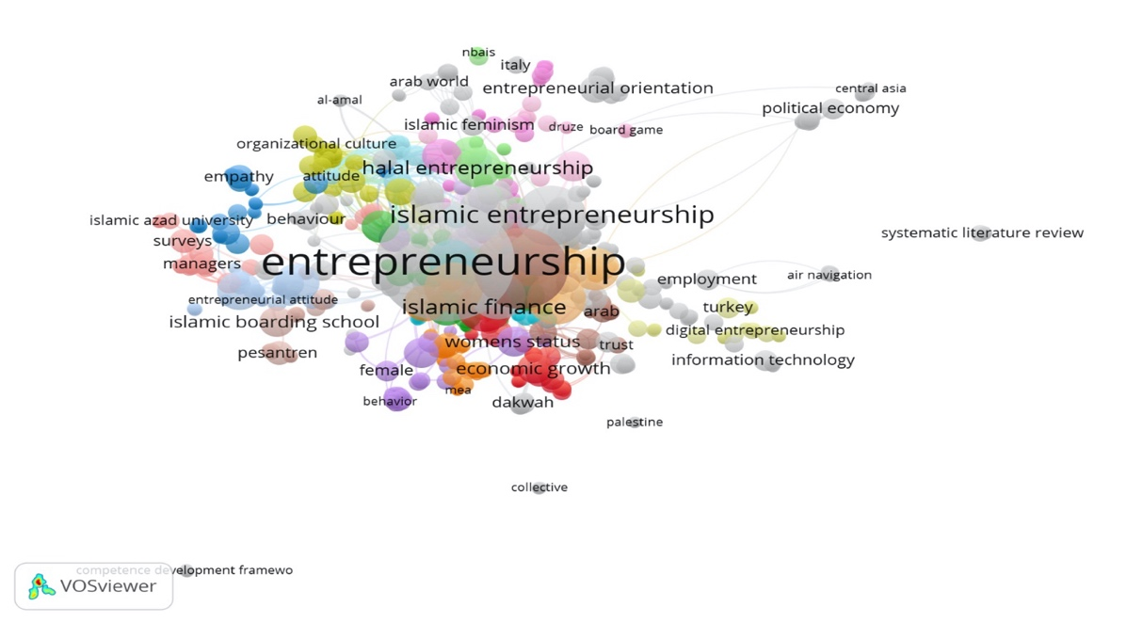

*Image Source 4: Your Viewer, 2024. Network Vizualitation*

The results of this Vos Viewer story, reveal that the more yellow the color it means that the research in the area of yellow as the lightest color is relatively new research of the variable, but on the other hand, if it is darker such as purple, blue and green colors have been researched by researchers before or years have passed, so that the variable can see which ones have just been researched and which have been researched for a long time. Examples of research on "islamic and university", "survey", "entrepreneurship", "managers", "arab world" have been carried out, but on the other hand such as "pesantren", "political economy", "systematic literature review", "al-amal" this shows that the research is just being carried out, can be seen in (figure 5).

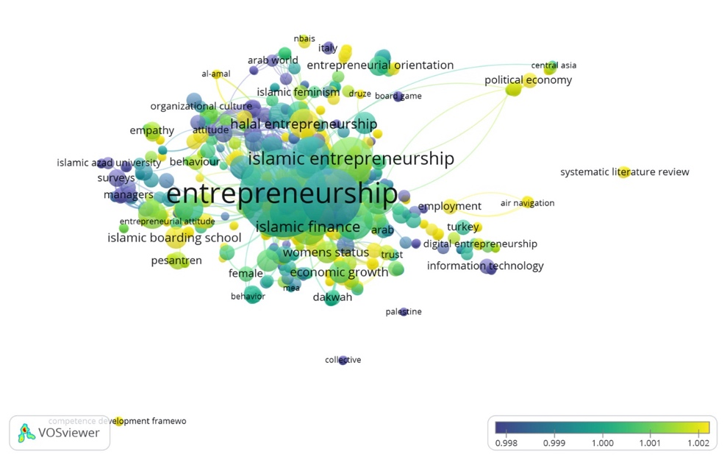

*Image Source 5: Vos Viewer, 2024, Vizualitation Overlay*

Furthermore, in the following image the results of the Vos Viewer can be seen the density of the entrepreneurshi research variable, illustrating that in contrast to the overlay image of figure 4, the lighter the color, the newer the research.

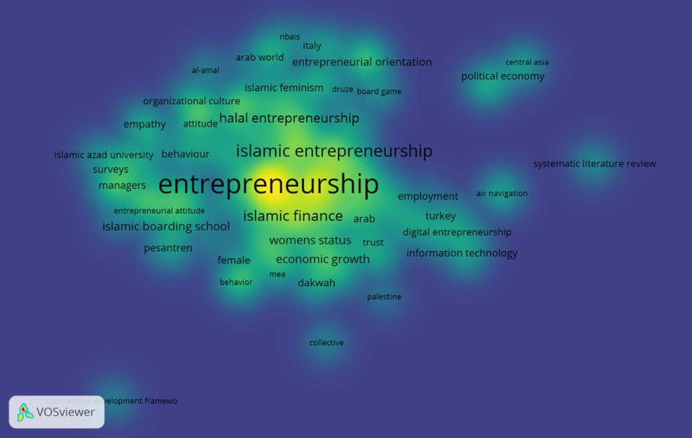

*Image Source 6: Vos Viewer, 2024, Density Visualization*

The results of the Vos Viewer show that in Desity Vizualization, the Systematic Literature Review research is still small that links to Islamic entrepreneurship, Islamic finance and the SDGs.

If Islamic entrepreneurship, Islamic finance and these 17 sustainable development (SDGs) are in line with the goals of Islamic law, which is the benefit of humanity. Such as the absence of poverty, no hunger and so on. Sustainable Islamic finance and the SDGs have the same goal, which is to move towards maslahah. Shari'a maqashid has several concepts such as (a) public interest (al-masalih. al-ammah), (b) interest (al-masalih. al-murs), (c) legal preference (istishan), (d) presumption of continuity (istishab), and (e) avoidance of damage (al-mafsadah).

The literature review provides evidence of the potential of Islamic Sustainable Finance (ISF) to contribute to sustainable development, especially through its alignment with the Sustainable Development Goals (SDGs) to avoid risks in the financial management of Islamic Finance products and later the financing products can be applied to halal-based entrepreneurship. There is potential in sustainable finance in supporting the Sustainable Development Goals (SDGs), this is because the principles of sustainable development support sustainable development (SDGs) because they are consistent with the sharia maqashid.

**CONCLUSION**

Research on Islamic entrepreneurship, Islamic finance and SDGs provides potential for Islamic finance, entrepreneurship, and SDGs are interesting topics if further researched such as Systematic Literature Review (SLR) research according to the results of Vos Viewer, this research is still far from the network, so it can be used as a gap for further research.

**REFERENCES**

Ahmed, H., & Aassouli, D. (2022). Entrepreneurial finance, agency problems and Islamic ethics: complementarities and constraints. *Venture Capital*, *24*(1), 25–46. https://doi.org/10.1080/13691066.2022.2067017

Awan, M. S., Zahid, M., & Sabir, M. (2023). Islamic Microfinance: A Shariah-Compliant Tool for Poverty Alleviation and Social Welfare. *Al-ISRA, 2*(01), 44–66.

Billah, M. M., Hassan, R., Haron, R., Rosman, R., & Naba'Billah, A. (2024). *Islamic Green Finance: A Research Companion*. Taylor & Francis.

Burhanudin Harahap, T. R. and I. N. F. (2023). Islamic Law, Islamic Finance, and Sustainable Development Goals: Systematic Literature Review (2-21, Trans.). *Copyright © Mdpi.Com/Journal/Sustainability*.

Chiu, S., Newberger, R., & Paulson, A. (2005). Islamic finance in the United States. *Society*, *42*(6), 64–68.

García-León, R., Martínez-Trinidad, J., & Campos-Silva, I. (2021). Historical Review on the Boriding Process using Bibliometric Analysis. *Transactions of the Indian Institute of Metals*, *74*. https://doi.org/10.1007/s12666-020-02174-6

Hagawe, H. M., Mobarek, A., Hanuk, A., & Jamal, A. (2023). A unique business model for microfinance institution: the case of Assadaqaat Community Finance (ACF). *Cogent Business and Management*, *10*(1). https://doi.org/10.1080/23311975.2022.2135202

Haron, R., & Siraj, M. A. (2024). Issues and Challenges of Sustainable Finance in the Islamic Capital Market. *Islamic Finance and Sustainable Development*, 195–208.

Hunjra, A. I., Arunachalam, M., & Hanif, M. (2024). The Role of Islamic Social Finance in Poverty Eradication. In *Islamic Finance in the Modern Era* (pp. 26–39). Routledge.

Hussein Kakembo, S., Abduh, M., & Pg Hj Md Salleh, P. M. H. A. (2021). Adopting Islamic microfinance as a mechanism of financing small and medium enterprises in Uganda. *Journal of Small Business and Enterprise Development*, *28*(4), 537–552.

Ilias, S. (2009). *Islamic finance: overview and policy concerns*.

Khan, F., & Haneef, M. A. (2022). Religious responses to sustainable development goals: An islamic perspective. *Journal of Islamic Monetary Economics and Finance*, *8*(2), 161–180.

Lukman Raimi, I. deniyi bdur-R. and S. folabi shafa. (2024). Does Islamic Sustainable Finance Support Sustainable Development Goals to Avert Financial Risk in the Management of Islamic Finance Products ? A Critical Literature Review. *MDPI,* 2.

María Isabel Esca lo na Fernández, P. L. B. P. G. (n.d.). *Web of Science vs. SCOPUS: A Quantitative Study in Chemical Engineering*.

Martínez-Falcó, J., Sánchez-García, E., Marco-Lajara, B., & Georgantzis, N. (2024). The interplay between competitive advantage and sustainability in the wine industry: a bibliometric and systematic review. In *Discover Sustainability* (Vol. 5, Issue 1). Springer Nature. https://doi.org/10.1007/s43621-024-00196-4

Mustafa Adli, Eng. and S. S. (2023). *ICD-Lseg Islamic Finance Development Report*.

Raimi, L., Adekunle, S. M., & Shabbir, M. S. (2023). *Contemporary Discourse of Halal and Islamic Entrepreneurship*. Springer.

Sholeh, M. M. A., Waston, Nirwana, A., & Mahmudulhassan, M. (2025). The Reasons of Lifelong Education for the Sustainable Development Goals (SDGs): the Islamic Epistimology Perspective. *Journal of Lifestyle and SDG'S Review*, *5*(2). https://doi.org/10.47172/2965-730X.SDGsReview.v5.n02.pe02988

Uzochukwu, B. S., Okeke, C. C., Ogwezi, J., Emunemu, B., Onibon, F., Ebenso, B., Mirzoev, T., & Mir, G. (2021). Exploring the drivers of ethnic and religious exclusion from public services in Nigeria: implications for sustainable development goal 10. *International Journal of Sociology and Social Policy*, *41*(5/6), 561–583.

Wu, H., Feng, Z., Sun, T., Li, R., & Zhao, H. (2024). Efficiency, sustainability, and resilience a trifecta for a green economic recovery through natural resource markets. *Resources Policy*, *88*, 104435. https://doi.org/https://doi.org/10.1016/j.resourpol.2023.104435

Yasin, A. A., Salikin, A. D., Jaelani, A., & Setyawan, E. (2023). Sustainability Of Muslim Family Livelihoods In The Perspective Of Sustainable Development Goals. *International Journal Of Humanities Education and Social Sciences*, *2*(6).

Yasmeen, K. (2024). Framework for Islamic social entrepreneurship. *Journal of Islamic Accounting and Business Research*, *ahead-of-print*. https://doi.org/10.1108/JIABR-08-2023-0256

Zaib, S. Z. M., Abdullah, A., Yasin, N. H. M., Abdullah, S. S., & Azmi, N. F. B. (2021). Motivations Aspect for the Adoption of Islamic Financing Among Halal Entrepreneurs in Malaysia. In A. B., H. A., & E. I. (Eds.), *International Conference on Business and Technology, ICBT 2020: Vol. 194 LNNS* (pp. 1410–1419). Springer Science and Business Media Deutschland GmbH. https://doi.org/10.1007/978-3-030-69221-6_105